CSA1708-ARTIFICIAL INTELLIGENCE
LAB EXPERIMENTS
Program 13 : Python Program to Implement Minimax Algorithm for Gaming
Aim
To develop a Python program to implement the Minimax algorithm for two-player adversarial games to determine the optimal move and utility value for the maximizing player.
Algorithm
1. Represent the game states and terminal utility scores using a game tree structure.
2. Define the leaf nodes with their evaluated terminal utility values.
3. Define the recursive Minimax function taking current depth, node index, player flag, leaf scores, and maximum tree depth.
4. If the current node is a terminal/leaf node (depth == max_depth), return its utility value.
5. If it is the Maximizing player's turn:
6. a. Initialize best_value to negative infinity (-infinity).
7. b. Recursively evaluate Minimax value for each child node with is_max = False.
8. c. Update best_value with the maximum of current best_value and child node evaluation.
9. d. Return best_value.
10. If it is the Minimizing player's turn:
11. a. Initialize best_value to positive infinity (+infinity).
12. b. Recursively evaluate Minimax value for each child node with is_max = True.
13. c. Update best_value with the minimum of current best_value and child node evaluation.
14. d. Return best_value.
15. Call the Minimax function starting at the root node (depth = 0, is_max = True).
16. Display the terminal scores and the computed optimal minimax value at the root.

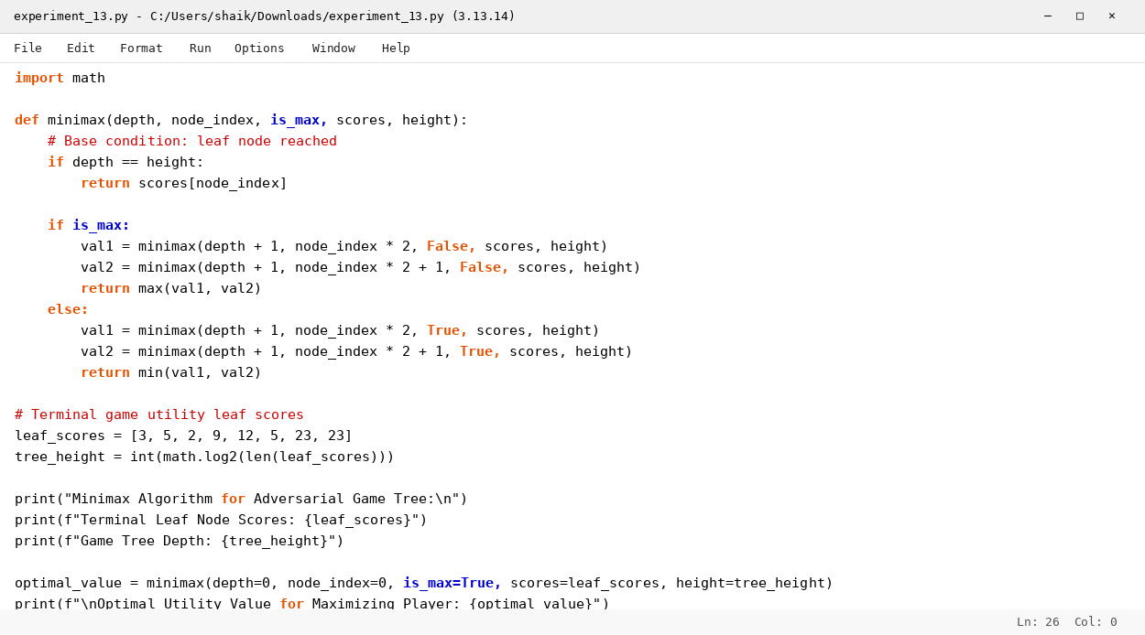

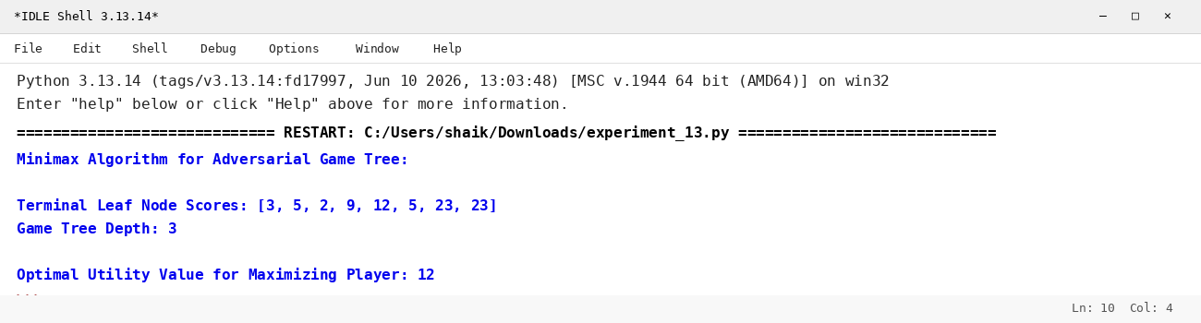

RESULT
Thus, the Minimax algorithm for gaming was implemented successfully using Python.

